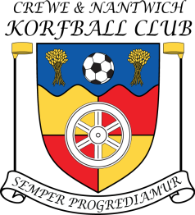
Chair’s Report, 2013-2014

After a rocky start to the 2013-14 season I’m pleased to report that CaNKorf has finished on a high with the additional of several new players and the return of some old faces too! The move to Malbank school has been a great success and I believe has been instrumental in re-energising the club. Here’s to more success over the next year! The highlights of the previous year in no particular order include:

The Comings and Goings of the Committee

- Due to dwindling numbers at the start of the season the committee has predominantly been a continuation of the previous year with meetings being held on a more informal basis.
- While there have been no official meetings this past year we have made some key changes to the running of the club. It was decided that we would make the move the adult training over to Malbank school in Nantwich in order to try and gain more members which has been a resounding success.

The Comings and Goings of the (Adult) Membership

- The number of regular members has increased significantly over recent months and we are now regularly getting ten or more players at training which is fantastic! We now have 6 boys regularly attending training (James, Rob, Ed, Pete, Liam, Dan) with Lewis frequently attending and 8 girls (Eleanor, Steph, Sarah, Chloe, Natasha, Claire, Regan, Alex) with Sophie Walley frequently playing matches and Dulcie and Hannah attending during the holidays.
- Moving on: On the negative side we have lost Kevin Lawton, Martin Lawton, Neil Sarginson and Lucy Jerome as regular players. However, both Lucy and Martin have gone off separately to raise the next generation of korfball players so I’m sure we can expect to see them again soon!
- New recruits: Over the last year we have seen a number of new recruits to CaNKorf and the return of an old player. Over the past year we have recruited Steph Lapsley, Liam Neill, Pete Styles, Ed McCauley, Chloe Blaxill, Natasha Mason with Dan Tomkinson returning after a gap year (or two).
- Nearly but not quite: We’ve had a few over the last year (Jess Davies) and others whose name(s) escape me (probably explains a bit!) who decided that Korfball was not for them. However, I think that the club has done very well with player recruitment this year and hopefully we can keep this up in the year to come.

The continued development of the club and its members

- Eleanor has continued with the role of club coach and has been doing a fantastic job in encouraging our new players and also helping to improve those of us who have been with the club for a while. I have also continued with my role running the junior section of the club with Eleanor stepping in while I have been away.
- Adult numbers have risen over the past year with all new players showing increasing confidence and ability which is great to see.
- Sadly junior membership has not shared the same level of success as the Adult division with around 3 – 5 regular attendees. On the plus side Alex, Tyler and Lewis will still attend the Adult sessions and are continuing to develop.
- What we need to develop as a club is the development of practically qualified referee’s and increase the number of qualified/practising referee’s within the club as currently Eleanor does the majority of reffing. I have refereed more games this season but we still need to continue our development in this area.

Competitions

- An excellent performance by the Express team this year (with a little help from guest players) with Express finishing top of the league!
- Sadly due to players having other commitments we have been unable to send a full team to the Manchester mini league or any summer tournaments this year. On both occasions though we did team up with Castle players and put in some good performances against some very tough opposition! Especially at the Leicester tournament where one team did the work of two and I know there were a lot of tired korfers after that one. There were some Crewe players at the Castle tournament this year which was a great day and hopefully we will be able to send a team to more events next year.

Finances

- Thanks largely to the continuing efforts of club treasurer Rob Barlow and the generosity of the club’s coaches (Eleanor coaching for free) the club’s bank balance is still quite healthy although the adult membership has been helping to subsidise the running of the junior division.

Youth Section

- Tyler, Alex and Lewis (when available) continue to train with both the juniors and also with the adults later on.
- Eleanor has been doing a brilliant job raising our profile by running taster sessions at St Marys
- Sadly there have not been as many opportunities to participate in other council events although we were in attendance at the Nantwich Societies Spectacular on the 19th July with a possibility of a joint Crewe/Castle venture to Dorfold Park at the beginning of August.
- There is still a gender imbalance within the junior section with the majority of members now being girls with Lewis being the only boy in attendance. We will need to find a way to bring more juniors into the club especially boys.
- All junior players have improved their korfball skills over the past year with some of them being able to give the adults a run for their money!

So, there are the highlights (and lowlights) of the past year that I can recall. After the setbacks of last year regarding numbers I believe that we have had a massive turn around and are in a much stronger position going into next year. Here’s to a very successful 2014/15…

Your chairperson,

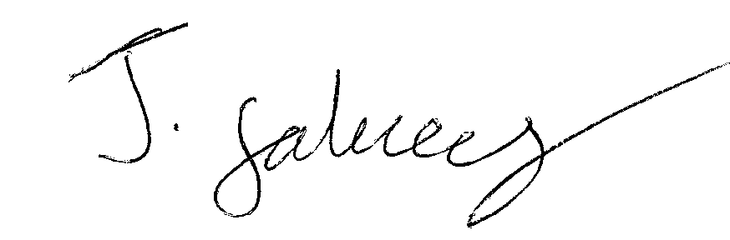James Falvey. July 21, 2014

